Priced is Right — Email Template
Indiana Association of REALTORS® | 2026 Research
This is a drop-in email or newsletter blurb you can send to seller leads, past clients, or your full list. It links back to the full IAR research article. Replace the bracketed bits with your name and contact info before sending. You can shorten or personalize the opening if you're sending to a specific lead.

Subject: Why pricing right matters more than ever
The Indiana Association of REALTORS® just published new research on how listing price affects days on market, and the findings are striking.
The overall market has slowed. The median home now takes 21 days to go under contract, up from 15 days in 2024. But that slowdown isn't hitting every listing equally.
Homes priced right are still going under contract in about a week — the same as two years ago. The extra days are almost entirely concentrated in overpriced listings. Every 1% over the eventual sale price adds about two and a half days on market on average, and a quarter of homes priced 4% too high are still sitting after 8 weeks.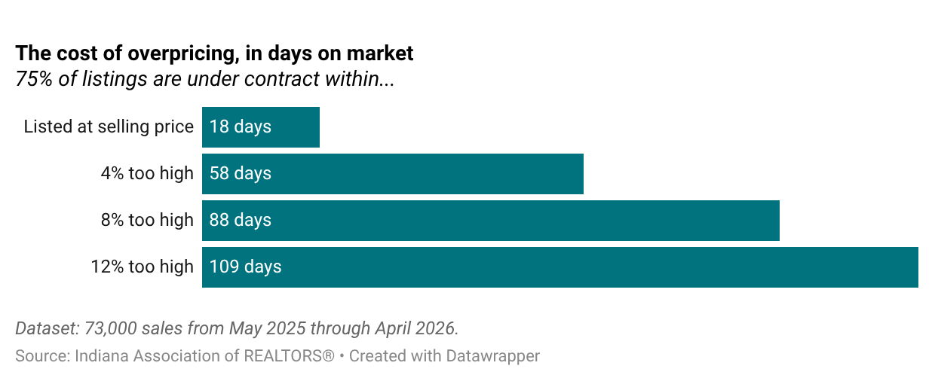
In today's market, listing price is the most consequential decision in the selling process. Get it right and you're largely insulated from the slowdown. Get it wrong and you absorb most of it.
Read the full analysis here.
[Your name] [Brokerage] [Phone | Email]

